# Acknowledgement

In the process of preparing my assignment, I sought assistance and guidance from individuals whom I deeply respect, and I am sincerely thankful to them.

I would like to begin by extending my heartfelt gratitude to ………………, my lecturer for the computer architecture module at ICBT Campus. His/Her valuable guidance and unwavering support during the numerous consultations were instrumental in shaping this assignment.

Furthermore, I want to convey my profound appreciation to my parents, friends, and colleagues who played an integral role in guiding and supporting me throughout this assignment. Their encouragement and assistance have been invaluable, and I am truly grateful for their contribution.

# Executive summery

The foundational aspect of the programming curriculum is the introductory section of the programming module, where we delve into the use of C++ as the primary programming language.

Within this module, our focus is on mastering the creation of a well-structured SRS (Software Requirements Specification) document based on a given scenario. Additionally, we extensively cover the production of comprehensive testing documentation and the development of error-free, efficient, and user-friendly software.

Regarding the SRS document, its primary function is to offer a clear and concise explanation of our project or software. It encompasses the project's purpose, requirements, and overall nature.

The testing documentation segment encompasses the formulation of a test plan, crafting specific test cases, and ultimately generating a comprehensive test report. These components collectively contribute to a definitive assessment of our project or software's performance and functionality.

In conclusion, software is essentially a compilation of code, a set of instructions, or a structured system of rules meticulously written in a specialized programming language. This module equips learners with the essential skills to excel in all these facets of software development.

Table of Contents

Acknowledgement 1

Executive summery 1

Table of Figures 3

Introduction 4

Task 01 4

System Requirements Specification and Logical Diagrams 4

Introduction: 4

Scope: 4

Functional Requirements: 5

Non-Functional Requirements: 6

Usability: 6

Performance: 6

Compatibility: 6

Flow charts according to the SRS of The Amber Bakery 7

Task 02 13

The System's Implementation 13

Login function 13

System Menu 15

19

Task 03 22

Test Document 22

Test Plan 22

Objective of the Test Plan for the Amber Bakery Automated Billing System 23

Functionality Validation: 23

Error Identification and Rectification: 23

Security and Access Control Testing: 23

Conclusion 26

References 26

# Table of Figures

Figure 0‑1 user login 7

Figure 0‑2 logout 8

Figure 0‑3 Manage item and package details 9

Figure 0‑4 Manage Sales details 10

Figure 0‑5 view Available Items 11

Figure 0‑6 View Company Details 12

# Introduction

At the heart of modern technology lies the art and science of programming. This intricate process involves the design and development of computer programs, which serve as the backbone of numerous applications we encounter daily. Through programming, we create sets of instructions, known as code, that computers can decipher and execute to accomplish specific tasks, ranging from basic calculations to complex data analysis.

For those embarking on a journey toward becoming software developers or delving into the realm of computer science, a solid understanding of programming principles is imperative. Mastery of programming opens doors to innovation and problem-solving, enabling individuals to bring their creative ideas to life through software applications and systems. As we delve deeper into the world of programming, we unlock the potential to shape the digital landscape and contribute to technological advancements that shape our modern society.

# Task 01

## System Requirements Specification and Logical Diagrams

### Introduction:

The Amber Bakery Automated Billing System is a comprehensive software solution designed to streamline and enhance the order management and billing processes of Amber Bakery, a renowned pastry shop in the UK. This system aims to replace the existing manual order placement system with an automated platform that efficiently manages customer orders, item details, sales records, and other relevant information. Additionally, the system will provide user authentication, access control, and the ability to view company details.

### Scope:

The scope of the Amber Bakery Automated Billing System encompasses the following functionalities:

* Viewing available bakery item details.
* Managing item and package details.
* Managing sales details.
* User authentication and authorization.
* User login and logout functionality.
* Exiting the system.
* Viewing company details.

## Functional Requirements:

Bakery Item Management:

* The system shall allow users to view a list of available bakery items with details such as name, description, price, and availability.
* Administrators shall have the capability to add, edit, or remove bakery items, including updating their attributes.

Package Management:

* Users with appropriate permissions shall be able to manage package details, including adding, modifying, and removing packages.
* Each package can include a combination of bakery items, with associated quantities and prices.

Sales Management:

* The system shall record and maintain sales details for each customer order, including the items purchased, quantities, prices, and total amount.
* Administrators shall be able to generate sales reports for specific time periods.

User Authentication and Access Control:

* The system shall support user registration, authentication, and authorization mechanisms.
* Users shall have different roles (e.g., customer, administrator) with corresponding access rights to various functionalities.

User Login, Logout, and Exit:

* The system shall provide a secure login mechanism for users.
* Users shall be able to log out to terminate their active sessions securely.
* An option to exit the system shall be available for users at any time.

Company Details:

* The system shall allow users to view essential company information, such as the bakery's history, contact details, and location.

## Non-Functional Requirements:

### Usability:

* The system shall have an intuitive and user-friendly interface to facilitate ease of use for both customers and administrators.

### Performance:

* The system shall be capable of handling a high volume of concurrent users without significant performance degradation.
* Response times for different operations should be within acceptable limits.

Security:

* User passwords shall be securely stored using encryption techniques.
* Access to sensitive functionalities and data shall be controlled based on user roles and permissions.

Reliability:

* The system shall be highly reliable, with minimal downtime for maintenance or upgrades.

### Compatibility:

* The system shall be compatible with common web browsers and operating systems.

## Flow charts according to the SRS of The Amber Bakery

User Login

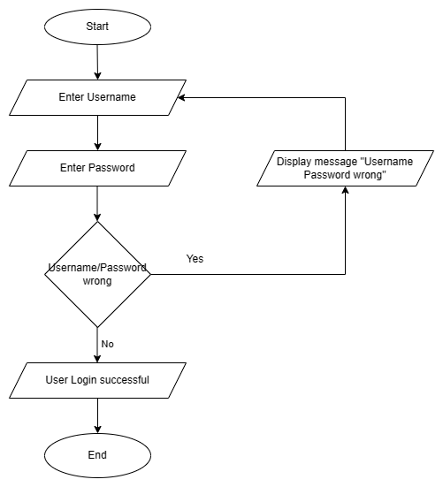

Figure ‑ user login

Logout

Figure ‑ logout

Manage item and package details

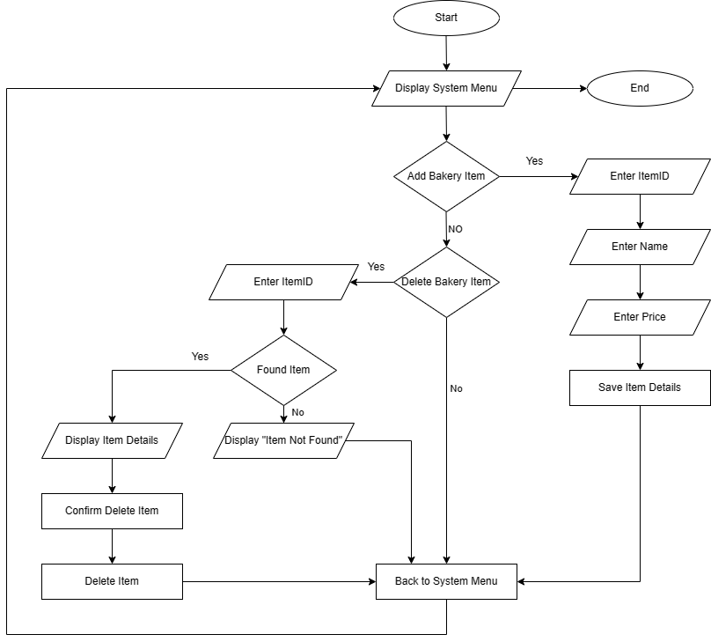

Figure ‑ Manage item and package details

Manage Sales details

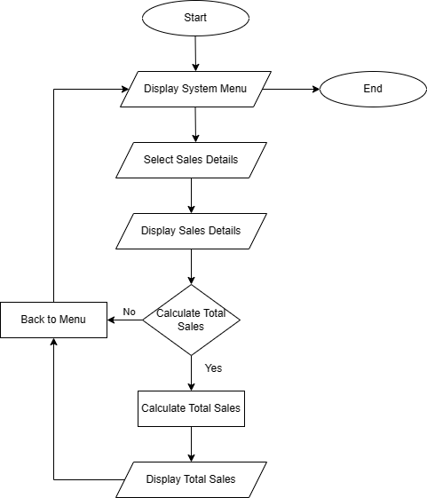

Figure ‑ Manage Sales details

View Available Items

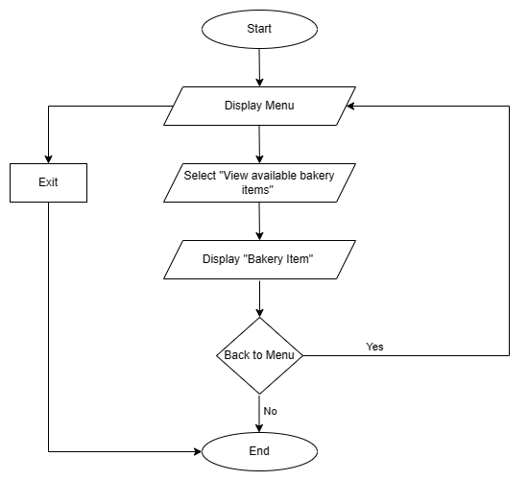

Figure ‑ view Available Items

View Company Details

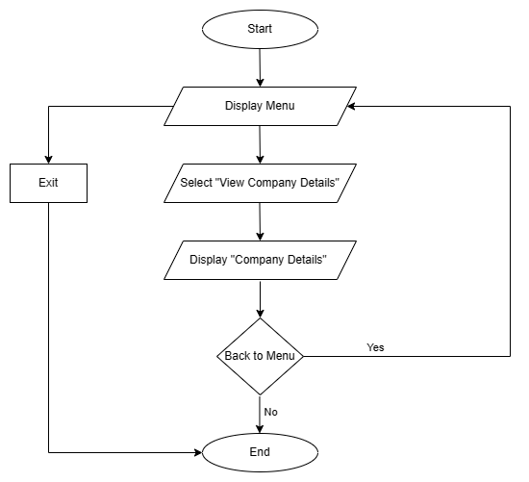

Figure ‑ View Company Details

# Task 02

## The System's Implementation

### Login function

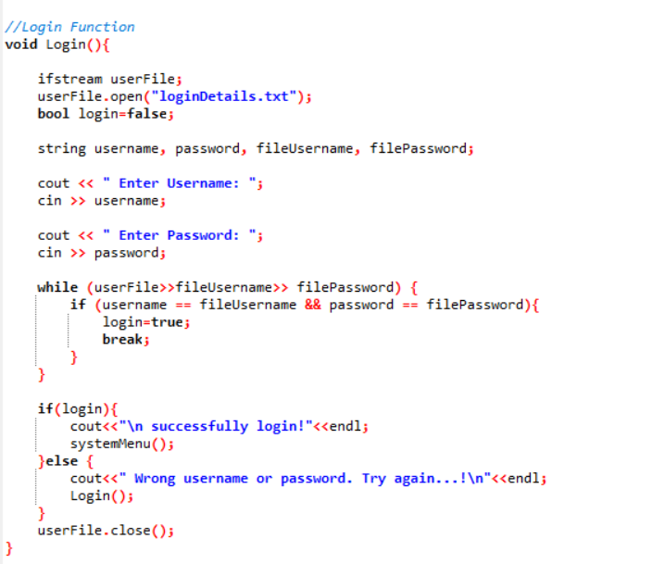The "Login" function is responsible for authenticating users and granting access to the system. It reads user-provided login credentials (username and password) and compares them with stored credentials from a file named "loginDetails.txt". If the entered credentials match any stored ones, the user is granted access and directed to the system menu. If the credentials do not match, the user is prompted to try again or exit.

Figure 7

Function Flow:

The function starts by opening the "loginDetails.txt" file for reading.

It initializes a boolean variable login to false.

The user is prompted to enter their username and password.

The function enters a loop that reads each line from the file, extracting the stored username and password and comparing them to the user's input.

If a match is found, the login variable is set to true, and the loop is exited.

If the login variable is true, the user is informed of a successful login, and the system menu is displayed.

If the login variable is false, an error message is shown, and the user is prompted to try logging in again.

If the user fails to log in after multiple attempts, the recursive nature of the code allows them to make additional attempts.

After the loop completes, the "loginDetails.txt" file is closed.

Logout, Exit, Move Back Funtions

Figure 8

### System Menu

The "System Menu" function is a core part of the Amber bakery automated billing system, offering users a menu-driven interface to access various functionalities. Users can make selections from a list of options, each corresponding to a specific operation within the system. The function reads the user's choice, performs the selected action, and allows for seamless navigation through different tasks. It also includes a mechanism for handling invalid selections and provides the option to log out of the system.

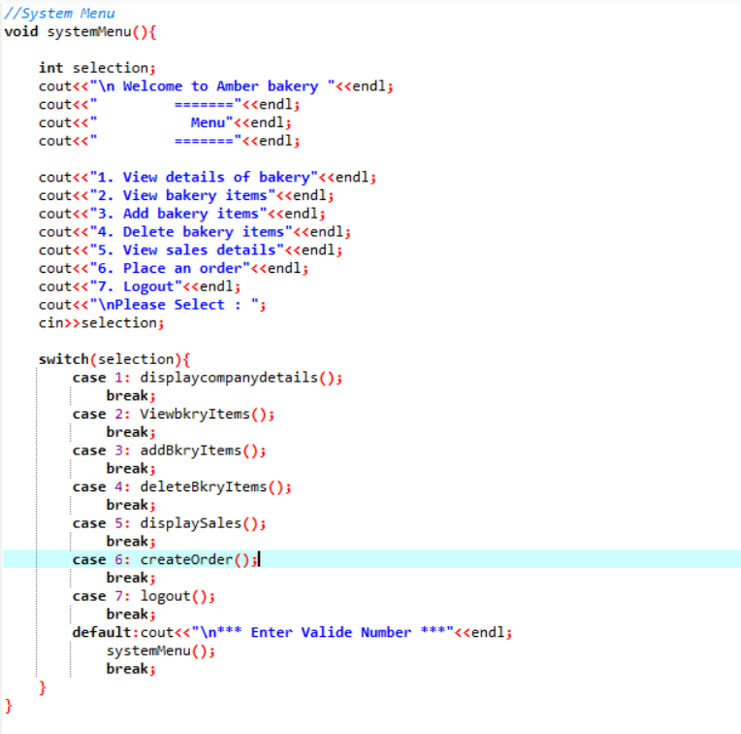

Figure 9

Display Company Information

The "Display Company Details" function presents information about Amber Bakery, providing users with insights into the bakery's reputation, location, contact details, and email address. The function allows users to go back to the previous menu by pressing '1'. It also handles validation to ensure proper user input, offering a user-friendly experience.

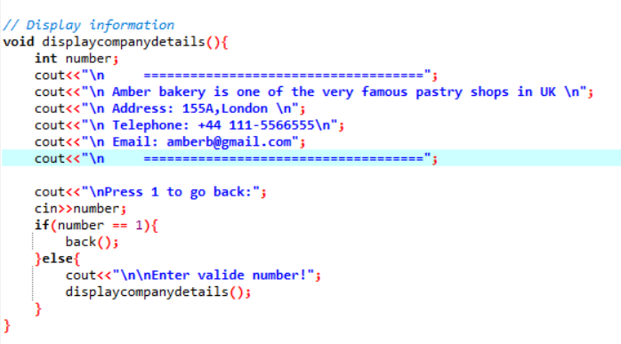

Figure 10

Add items function

The "Add Bakery Items" function allows users to input details for new bakery items and appends this information to a file named "ItemDetails.txt." Users provide information such as Item ID, Item Name, and Item Price. After successfully adding an item, users are given the option to go back to the previous menu by pressing '1'. The function also includes validation to ensure proper user input.

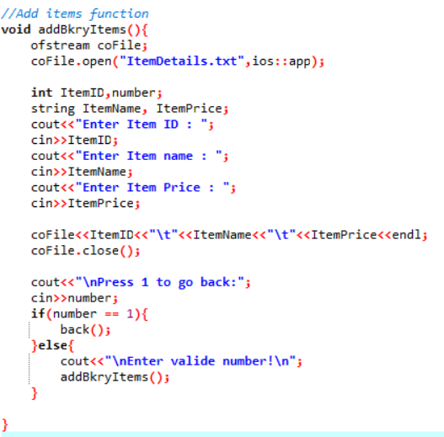

Figure 11

Key Points:

The function opens the "ItemDetails.txt" file in append mode, allowing new item details to be added without overwriting existing data.

Users input the Item ID, Item Name, and Item Price for the new bakery item.

The function writes the item details to the file in a tab-separated format: ItemID, ItemName, and ItemPrice.

After successfully adding the item, the "ItemDetails.txt" file is closed.

Users are prompted to press '1' to return to the previous menu.

If the input is '1', the function calls the back() function to return to the previous menu.

If the input is not '1', the function displays an error message and recursively calls itself to prompt the user for a valid input.

This function streamlines the process of adding new bakery items to the system, contributing to efficient bakery item management.

View Items function

The "View Bakery Items" function allows users to see a list of bakery items and their details, which are stored in the "ItemDetails.txt" file. The function displays information such as Item ID, Item Name, and Item Price for each bakery item. Users are given the option to go back to the previous menu by pressing '1'. The function also includes validation to ensure proper user input.

Figure 12

Delete function

The "Delete Bakery Items" function enables users to remove bakery items from the system. Users specify the Item ID of the item they want to delete, and the function processes the deletion by updating the "ItemDetails.txt" file. After deleting an item, users are given the option to go back to the previous menu by pressing '1'. The function also includes validation to ensure proper user input.

# 

Figure 13

Read Sales details

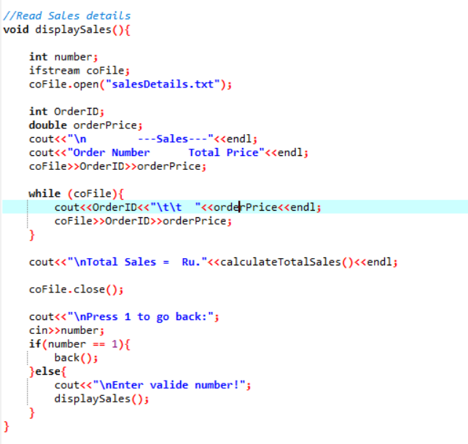

Figure 14

Calculate total sales function

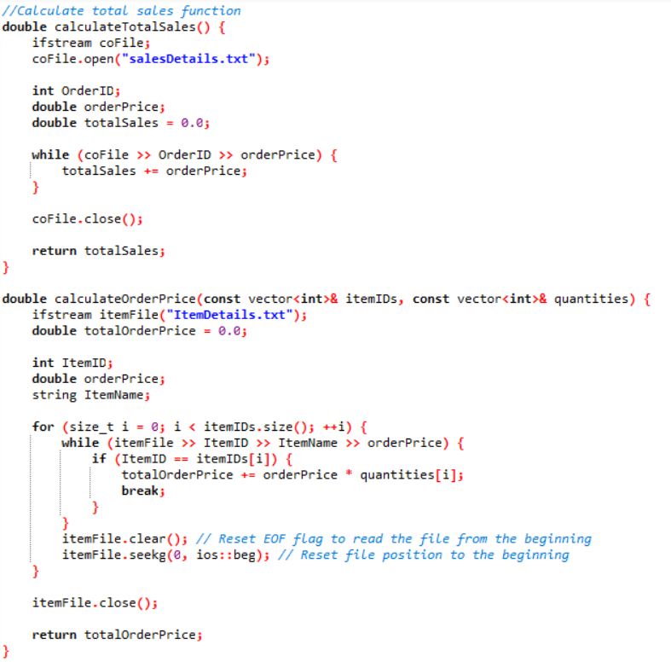

Generate OrderID function

CreateOrder function

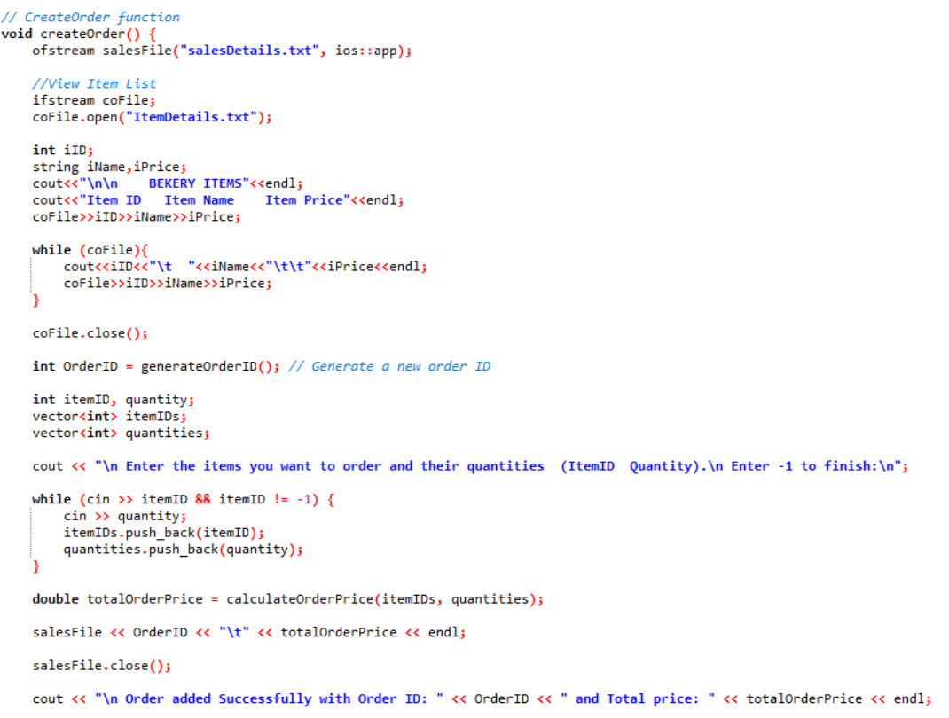

# Task 03

## Test Document

# Test Plan

A test plan is a systematic and organized testing technique that aims to ensure the dependability and excellence of the hardware or software being tested. It aligns testing activities with the project's requirements, fostering good communication between the testing team and other stakeholders. This methodical approach strengthens the testing procedure, ultimately resulting in increased dependability and quality of the tested product.

The test plan ensures alignment with project requirements, provides comprehensive testing coverage, and is efficient in resource planning. It also fosters effective communication among the testing team, project stakeholders, and relevant parties, promoting shared understanding of the testing approach, objectives, and timelines. Risk identification and mitigation are also included in the test plan, allowing for the development of appropriate mitigation strategies to minimize their impact on the testing process and the overall project.

The test plan plays a role in ensuring the quality of the tested software or hardware, establishing criteria for test completion and success, enabling the testing team to evaluate and verify if the system meets the required quality standards. It also provides documentation and traceability by linking test cases, scripts, and other artifacts to corresponding requirements or specifications, enhancing documentation and accountability.

In conclusion, a test plan is essential for organizations to implement a methodical and organized approach to testing, ultimately improving the overall quality of the product or system under development.

## Objective of the Test Plan for the Amber Bakery Automated Billing System

The objective of the test plan for the Amber Bakery Automated Billing System is to ensure the robustness, reliability, and optimal performance of the software application. This comprehensive testing strategy is designed to systematically identify, assess, and rectify any defects, vulnerabilities, or discrepancies within the system's functionalities. The primary goals of the test plan include:

### Functionality Validation:

The test plan aims to thoroughly validate the functionality of the Amber Bakery Automated Billing System. It seeks to confirm that all specified requirements, including the ability to view bakery item details, manage item and package information, handle sales records, and other associated tasks, are implemented accurately and perform as intended.

### Error Identification and Rectification:

The test plan's objective is to identify and report any errors, bugs, or glitches present within the system. By conducting systematic testing procedures, the plan aims to pinpoint anomalies in the software's behavior, data processing, and user interactions. Once identified, these issues will be addressed and resolved to ensure a seamless user experience.

### Security and Access Control Testing:

Security testing is an integral part of the test plan's objective. It aims to validate the system's robustness against potential security threats, ensuring that user authentication, authorization, and data protection mechanisms are effective. Any vulnerabilities discovered will be addressed to safeguard sensitive information.

By achieving these objectives, the test plan for the Amber Bakery Automated Billing System aims to deliver a thoroughly tested, high-quality software application that meets the bakery's requirements, exceeds customer expectations, and contributes to the bakery's operational efficiency and success.

**Testing Methodology:**

* Manual testing will be conducted.
* Functional testing will be done to verify that all functions work as intended.

|  |  |  |  |
| --- | --- | --- | --- |
| Requirements | System Login | | |
| Test | Developer | | |
| Date Schedule: 24/08/2023 | | Date Conducted: 24/08/2023 | |
| Input | Sample Data | Expected Result | Actual Result |
| Valid | Username=”admin”  Password=”1234” | “Logging Success” | Pass |
|  |  |  |  |
| Invalid | Username”Admn”  Password=”2345” | “Logging Failed” | Fail |
|  |  |  |  |

Table 1 System Login

|  |  |  |  |
| --- | --- | --- | --- |
| Requirements | Add Item | | |
| Test | Developer | | |
| Date Schedule: 24/08/2023 | | Date Conducted: 24/08/2023 | |
| Input | Sample Data | Expected Result | Actual Result |
| Input Item Details | ItemID=2  ItemName=”Cake”  Price=975.00 | Display “Added Item” | Display Added Item |
|  |  |  |  |
| Input Invalid Price | ItemID=2  ItemName=”Cake”  Price=WTR | Display “Input Valid Price” | Fail |
|  |  |  |  |

Table 2 Add Items

|  |  |  |  |
| --- | --- | --- | --- |
| Requirements | Delete Item | | |
| Test | Developer | | |
| Date Schedule: 24/08/2023 | | Date Conducted: 24/08/2023 | |
| Input | Sample Data | Expected Result | Actual Result |
| Delete Item | ItemID=2  ItemName=”Cake”  Price=975.00 | Display “Item Deleted” | Display “Item Deleted” Message |
|  |  |  |  |

Table 3 Delete Item

|  |  |  |  |
| --- | --- | --- | --- |
| Requirements | Display Sales | | |
| Test | Developer | | |
| Date Schedule: 24/08/2023 | | Date Conducted: 24/08/2023 | |
| Input | Sample Data | Expected Result | Actual Result |
| Enter option | Option = 2 | “Display Sales” | Pass |
|  |  |  |  |
| Enter Invalid option | Option = 0 | Display “Enter Valid Number “ | Fail |
|  |  |  |  |

Table 4 Display Sales

|  |  |  |  |
| --- | --- | --- | --- |
| Requirements | Display Available Items | | |
| Test | Developer | | |
| Date Schedule: 24/08/2023 | | Date Conducted: 24/08/2023 | |
| Input | Sample Data | Expected Result | Actual Result |
| Enter option | Option = 1 | Display Available Items | Pass |
|  |  |  |  |
| Enter Invalid option | Option = 0 | Display “Enter Valid Number “ | Fail |
|  |  |  |  |

Table 5 Display Available Items

|  |  |  |  |
| --- | --- | --- | --- |
| Requirements | View Company Details | | |
| Test | Developer | | |
| Date Schedule: 24/08/2023 | | Date Conducted: 24/08/2023 | |
| Input | Sample Data | Expected Result | Actual Result |
| Enter option | Option = 3 | Display Company Details | Pass |
|  |  |  |  |
| Enter Invalid option | Option = 0 | Display “Enter Valid Number “ | Fail |
|  |  |  |  |

Table 6 View Company Details

# Conclusion

The Amber Bakery Automated Billing System aims to modernize the bakery's order management process by automating various tasks related to order placement, item management, sales records, and user authentication. This comprehensive software solution will enhance the efficiency and accuracy of operations while providing an improved experience for both customers and administrators at Amber Bakery.

# References

Anon., n.d. *belitsoft.* [Online]   
Available at: https://belitsoft.com/custom-elearning-development/srs-for-e-learning-management-system  
[Accessed 21 January 2023].

Anon., n.d. *softwaretestinghelp.* [Online]   
Available at: https://www.softwaretestinghelp.com/rview-srs-document-and-create-test-scenarios-software-testing-training-course-day-2/

Anon., n.d. *w3schools.* [Online]   
Available at: https://www.w3schools.com/cpp/cpp_conditions.asp

www.pmi.org. (n.d.). *Program Management Certification | PgMP*. [online] Available at: https://www.pmi.org/certifications/program-management-pgmp.

‌

MacDonald, M. (2020). *Modular programming: Definitions, benefits, and predictions*. [online] Blueprint - Blog by Tiny. Available at: https://www.tiny.cloud/blog/modular-programming-principle/.

‌

Coursera. (n.d.). *What Is Programming? And How To Get Started*. [online] Available at: https://www.coursera.org/articles/what-is-programming.